Title:
Create a customized Docker image using a Dockerfile.
Objective:
To create a customized Docker image using a Dockerfile and run a container from the built image.
Step by Step Implementation
Step 1: Create a Project Directory
mkdir docker_challange
cd docker_challange
Step 2: Create a Dockerfile
Vi Dockerfile
Step 3: Write the Dockerfile
Custom Nginx Image with Static Website
And add data into it
FROM nginx:latest
COPY ./index.html /usr/share/nginx/html/index.html
EXPOSE 8080
CMD ["nginx", "-g", "daemon off;"]
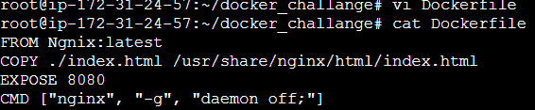
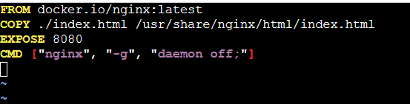
Step 4: Create a Custom Web Page
touch index.html
<h1>Hello from my Custom Docker Image!</h1>
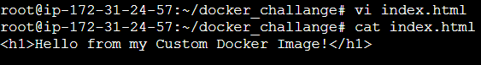
Step 5: Build the Docker Image
docker build -t my-custom-nginx .
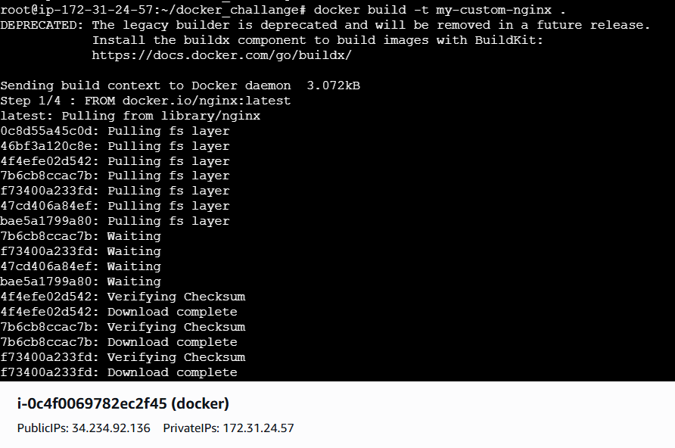
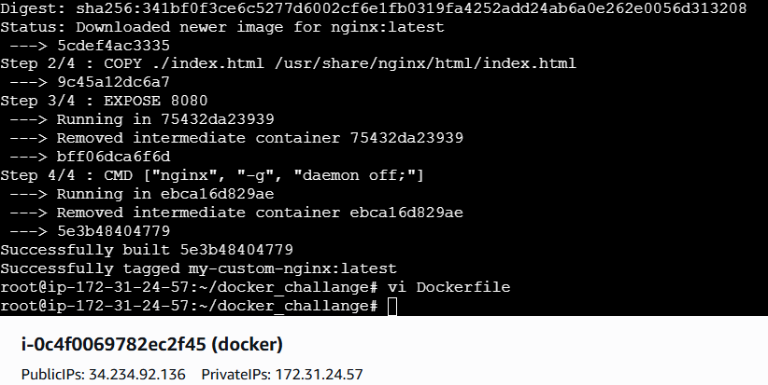
And Verify using docker images
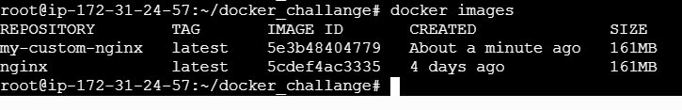
Step 6: Run the Container
docker run -d -p 8080:80 my-custom-nginx
Step 7: Verify
Open browser:
http://publicip:8080
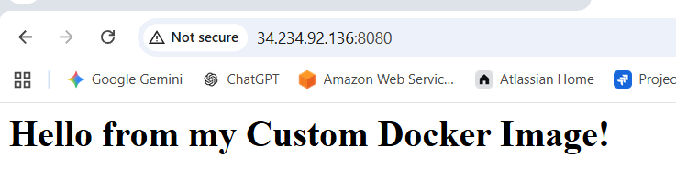

Errors I faced :
pull access denied for nginx, repository does not exist or may require 'docker login'
denied: requested access to the resource is denied
Even though you successfully logged in, Docker still can’t pull nginx:latest.
Why This Is Happening
On fresh servers / EC2 instances, this usually happens because:
Docker is trying to pull from the wrong registry
Docker is not explicitly told to use Docker Hub
Fix:
🔹 Update the FROM line in Dockerfile
Use the fully qualified image name:
FROM docker.io/nginx:latest
Conclusion
A custom Docker image was successfully created using a Dockerfile, built with the docker build command, and executed as a container, demonstrating basic Docker image creation and containerization concepts.

Title:
Push the image to Docker Hub.
Objective
To push a custom Docker image to Docker Hub using Docker commands.
Step by Step implementation:
Step 1: Login to Docker Hub
docker login
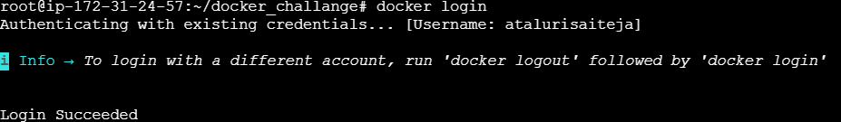
Step 2: Tag the Docker Image
docker tag my-custom-nginx atalurisaiteja/devops:latest
Step 3: Verify Image Tag
docker images
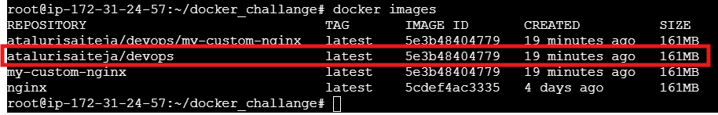
Step 4: Push Image to Docker Hub
docker push atalurisaiteja/devops:latest
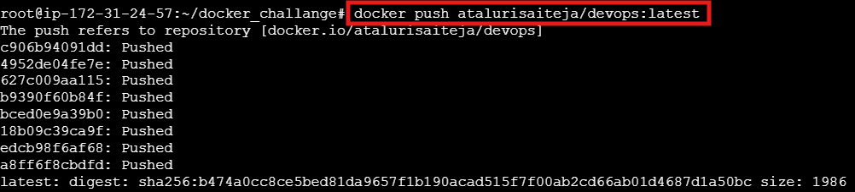

Step 5: Verify on Docker Hub
- Login to Docker Hub website
- Check the repository under your account
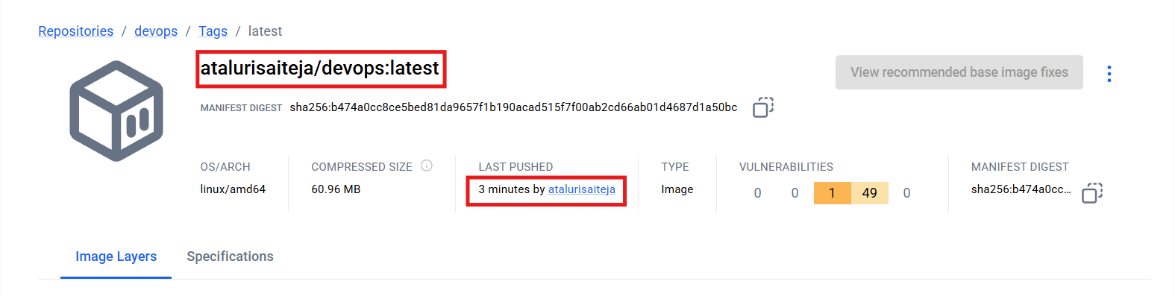
Errors faced:
requested access to the resource is denied
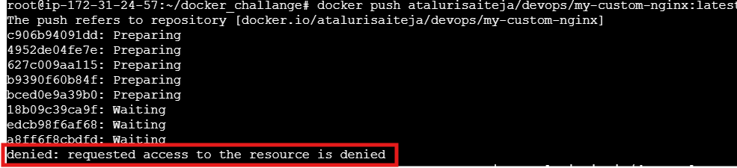
Error Explained:
Docker authenticated you, but Docker Hub is saying:
“You don’t have permission to push to this repository path.”
You are pushing to:
atalurisaiteja/devops/my-custom-nginx
That means:
- atalurisaiteja → your Docker Hub username ✅
- devops/my-custom-nginx → nested repository
Docker Hub does NOT allow nested repositories unless explicitly created and owned.
Conclusion
The Docker image was successfully tagged and pushed to Docker Hub, making it available for sharing and reuse from a remote image repository.
Title:
Push the same image to Amazon ECR.
Objective:
To push a Docker image to Amazon Elastic Container Registry (ECR).
Step by Step Implementation:
Step 1: Create an ECR Repository
aws ecr create-repository --repository-name my-custom-nginx
Im already having a existing repo in aws
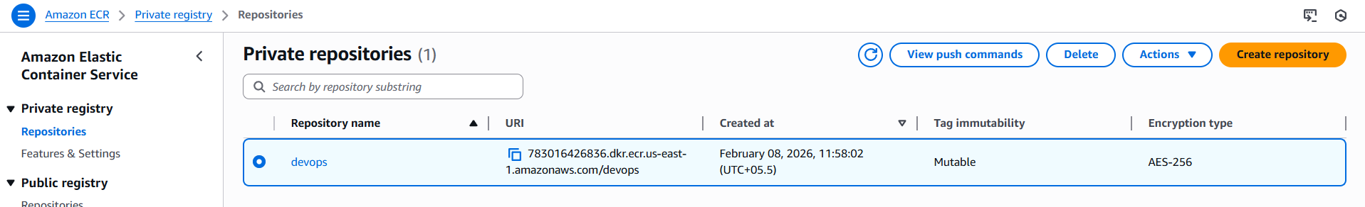
Step 2: Authenticate Docker to Amazon ECR
aws ecr get-login-password --region <region> \
| docker login --username AWS --password-stdin <aws_account_id>.dkr.ecr.<region>.amazonaws.com
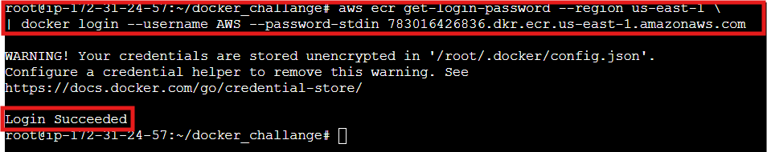
Step 3: Tag the Docker Image
docker tag my-custom-nginx:latest \
<aws_account_id>.dkr.ecr.<region>.amazonaws.com/devops:latest

Step 4: verify the images
docker images
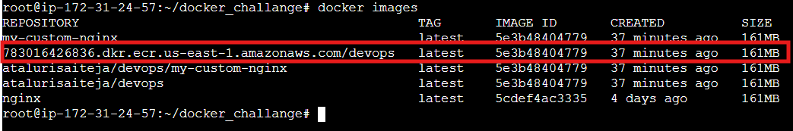
Step 5: Push the Image to ECR
docker push <aws_account_id>.dkr.ecr.<region>.amazonaws.com/devops:latest
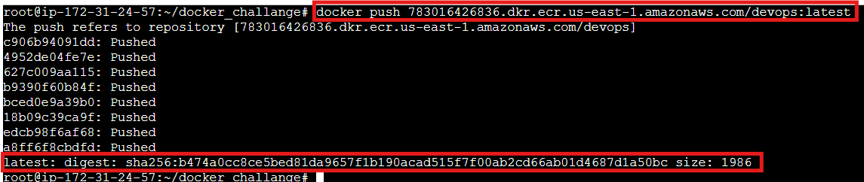
Step 6: Verify in AWS Console
- Open Amazon ECR
- Select repository devops
- Confirm the image tag latest
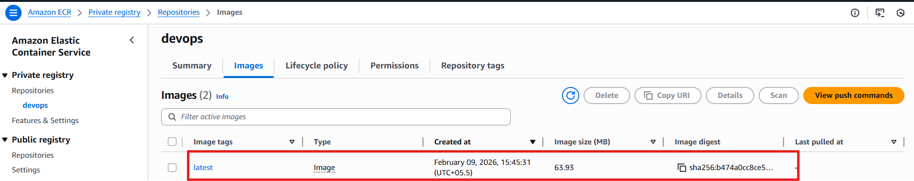
Conclusion:
The Docker image was successfully tagged and pushed to the existing Amazon ECR repository named devops.

Title:
Provision one EC2 instance using Terraform and install Jenkins.
Objective
To provision an EC2 instance using Terraform with configurable variables and install Jenkins.
Project Structure:
terraform-jenkins/
├── main.tf
├── variables.tf
└── terraform.tfvars
Syntax::
Main.tf::
provider "aws" {
region = var.region
}
resource "aws_instance" "jenkins" {
ami = var.ami_id
instance_type = var.instance_type
key_name = var.key_name
vpc_security_group_ids = var.security_group
root_block_device {
volume_size = 20
volume_type = "gp3"
}
user_data = <<-EOF
#!/bin/bash
yum update -y
yum install java-17-amazon-corretto -y
echo 'JAVA_HOME="/usr/lib/jvm/java-17-amazon-corretto"' >> /etc/sysconfig/jenkins
wget -O /etc/yum.repos.d/jenkins.repo https://pkg.jenkins.io/redhat-stable/jenkins.repo
rpm --import https://pkg.jenkins.io/redhat-stable/jenkins.io.key
yum install jenkins -y
systemctl daemon-reexec
systemctl enable jenkins
systemctl start jenkins
EOF
tags = {
Name = "jenkins_terraform"
}
}

Variables.tf::
variable "region" {
type = string
}

variable "ami_id" {
type = string
}

variable "instance_type" {
type = string
}

variable "key_name" {
type = string
}

variable "security_group" {
type = list(string)
}

variable "vpc_id" {
type = string
}

Terraform.tfvars::
region = "us-east-1"
ami_id = "ami-0532be01f26a3de55"
instance_type = "m7i-flex.large"
key_name = "sshless"
security_group = ["sg-03c2dac87fe225fb9"]
vpc_id = "vpc-011b327b9a8b73dd2"
outputs.tf::
output "instance_id" {
description = "EC2 Instance ID"
value = aws_instance.jenkins.id
}

output "public_ip" {
description = "Public IP of Jenkins EC2"
value = aws_instance.jenkins.public_ip
}

output "public_dns" {
description = "Public DNS of Jenkins EC2"
value = aws_instance.jenkins.public_dns
}

output "jenkins_url" {
description = "Jenkins Web URL"
value = "http://${aws_instance.jenkins.public_ip}:8080"
}

Step by Step implementation:
Step 1: terraform init
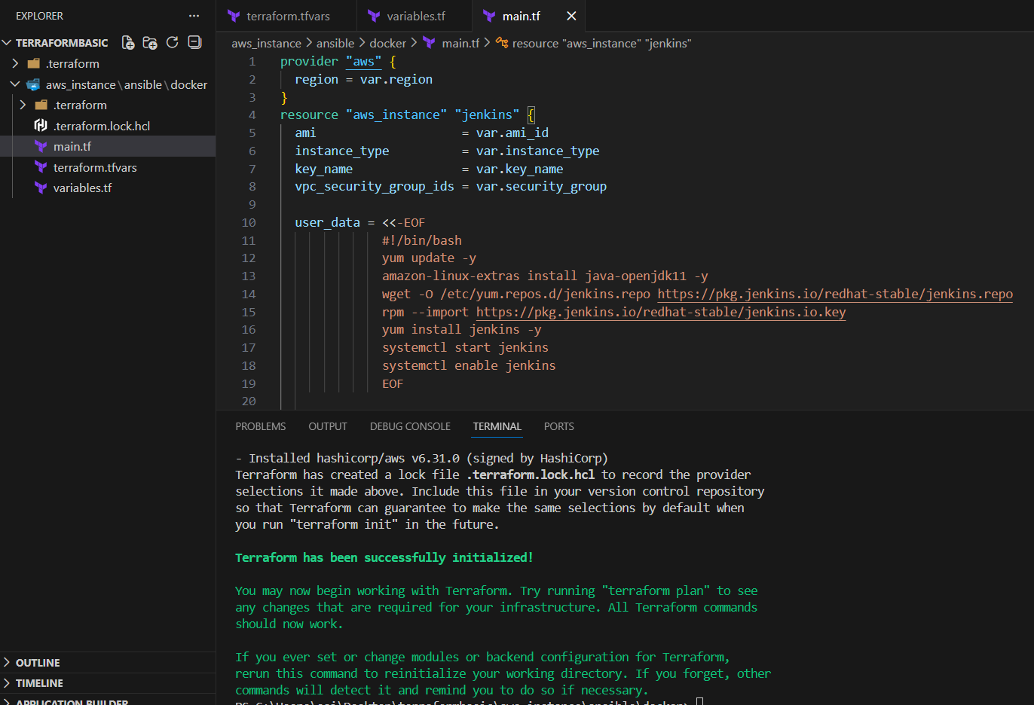
Step 2: terraform apply
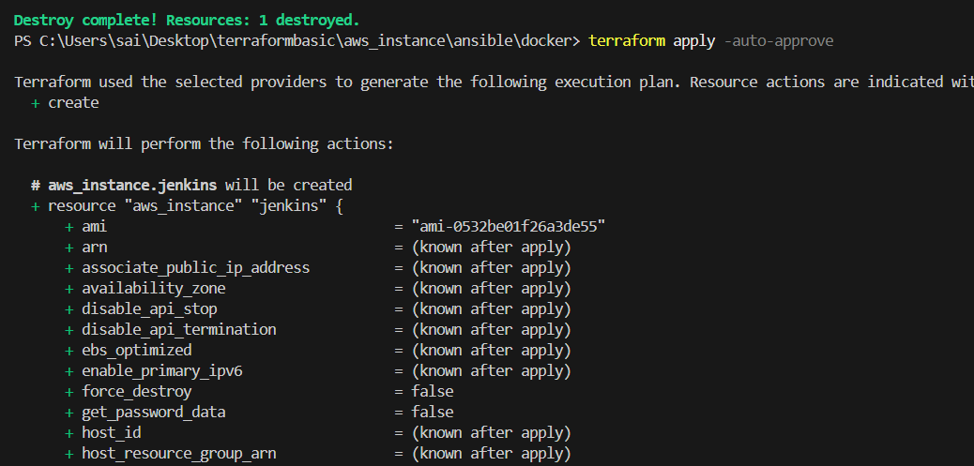

Step 3: verify on browser
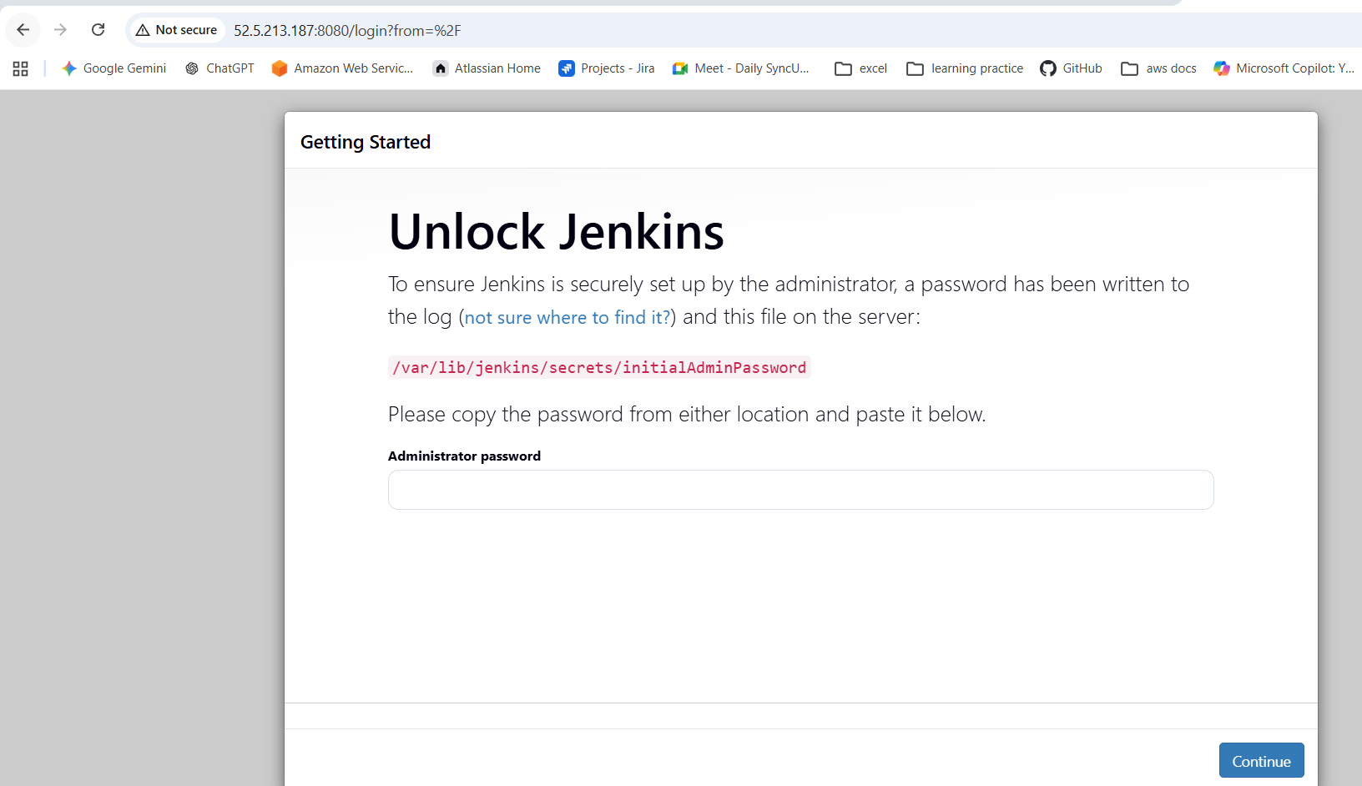
Description:
An EC2 instance was provisioned on AWS using Terraform to automate infrastructure creation. Jenkins was installed and configured on the EC2 instance during launch using a user data script. The Terraform configuration was organized using four separate files: main.tf for resource creation, variables.tf for declaring input variables, terraform.tfvars for securely passing environment-specific values and credentials, and outputs.tf for displaying important resource information after deployment. This approach improved security, reusability, and maintainability by avoiding hardcoded credentials and following Terraform best practices.
Conclusion:
The EC2 instance was successfully provisioned using Terraform and Jenkins was installed and configured automatically. Using separate Terraform files improved security, reusability, and infrastructure management.

Title:
Create one Jenkins job to build and push the Docker image to Docker Hub.
- Source: https://github.com/betawins/Python-app.git
Objective
To create a Jenkins job that builds a Docker image and pushes it to Docker Hub.
Steps to Create Jenkins Job (Build & Push Docker Image)
Prerequisites
- Jenkins running
- GIT
- Install Plugins of GIT, Docker on Jenkins GUI
- Docker installed on Jenkins server
- Docker Hub account
- Docker Hub credentials added in Jenkins
(Manage Jenkins → Credentials → Add Username & Password)
Step By Step Implementation:
STEP 1: Install git on server:
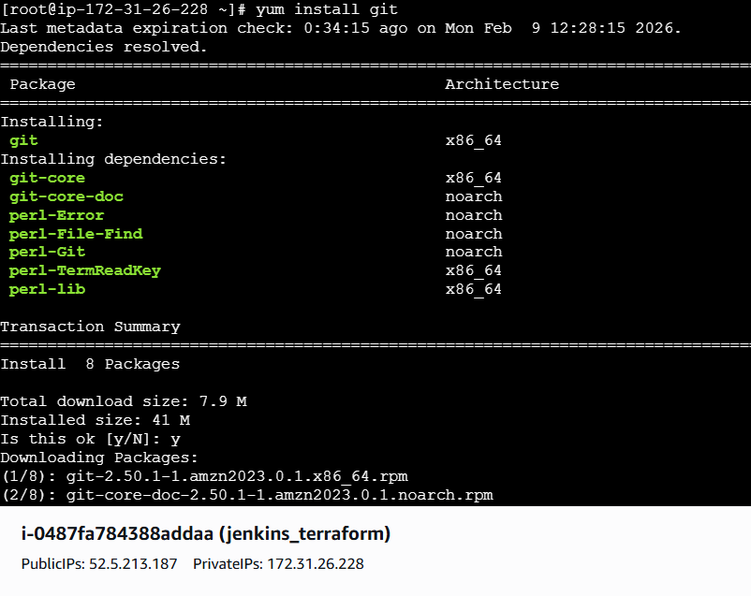
Step 2: Install Docker on Server
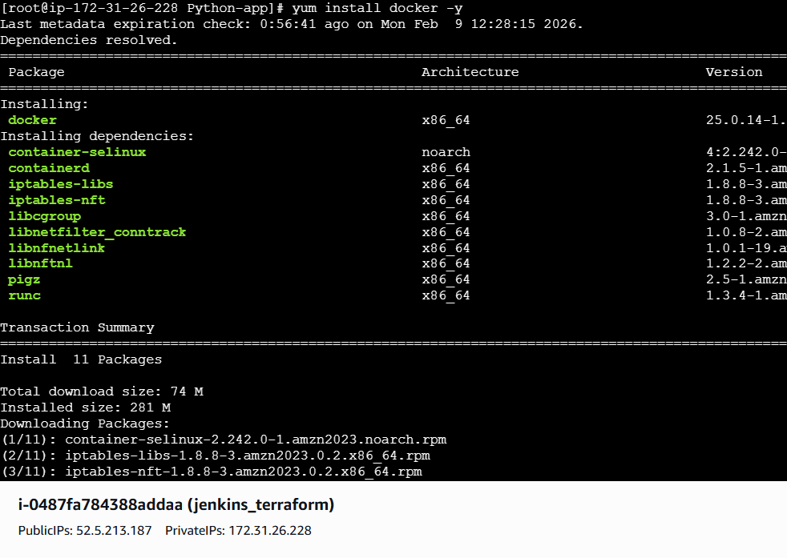
Step 3: Add credentials of Docker hub username and password
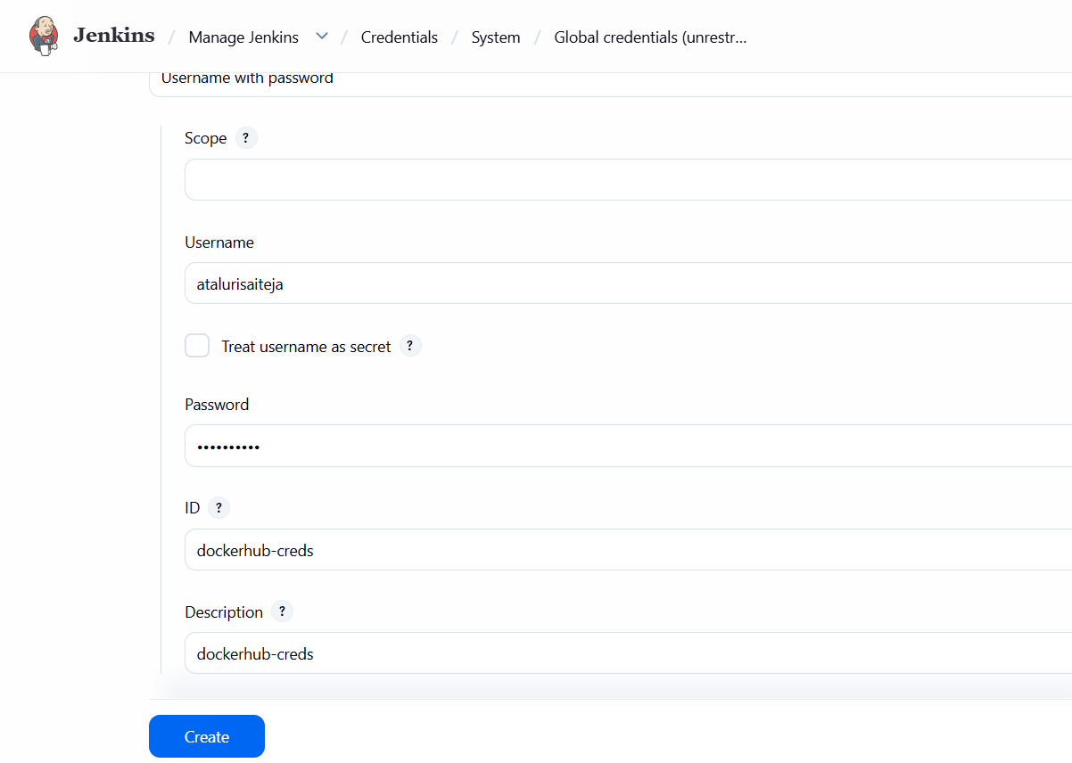
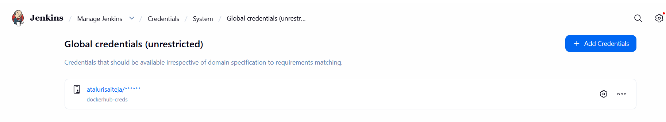

Step 4: Create a Jenkins Job
- Open Jenkins Dashboard
- Click New Item
- Enter job name (e.g., docker-build-push)
- Select Pipeline
- Click OK
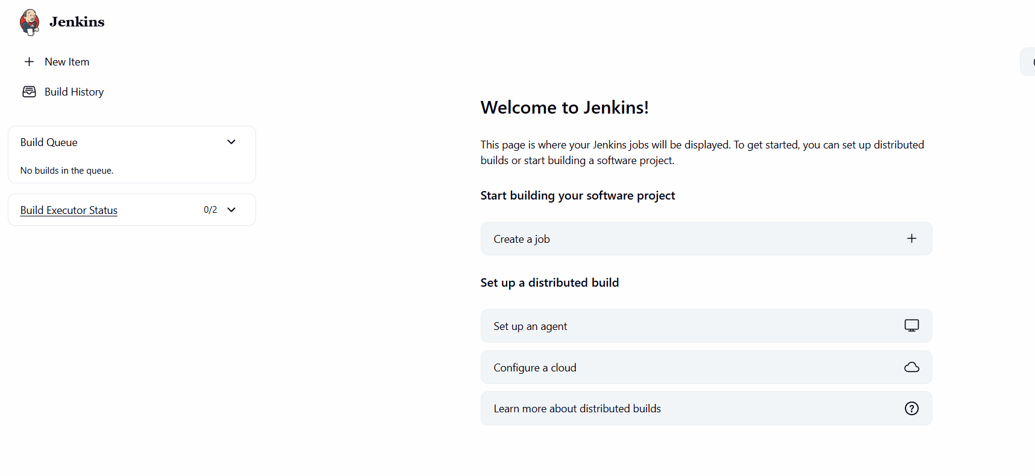
Save and Build
- Click Save
- Click Build Now
- Check Console Output for success
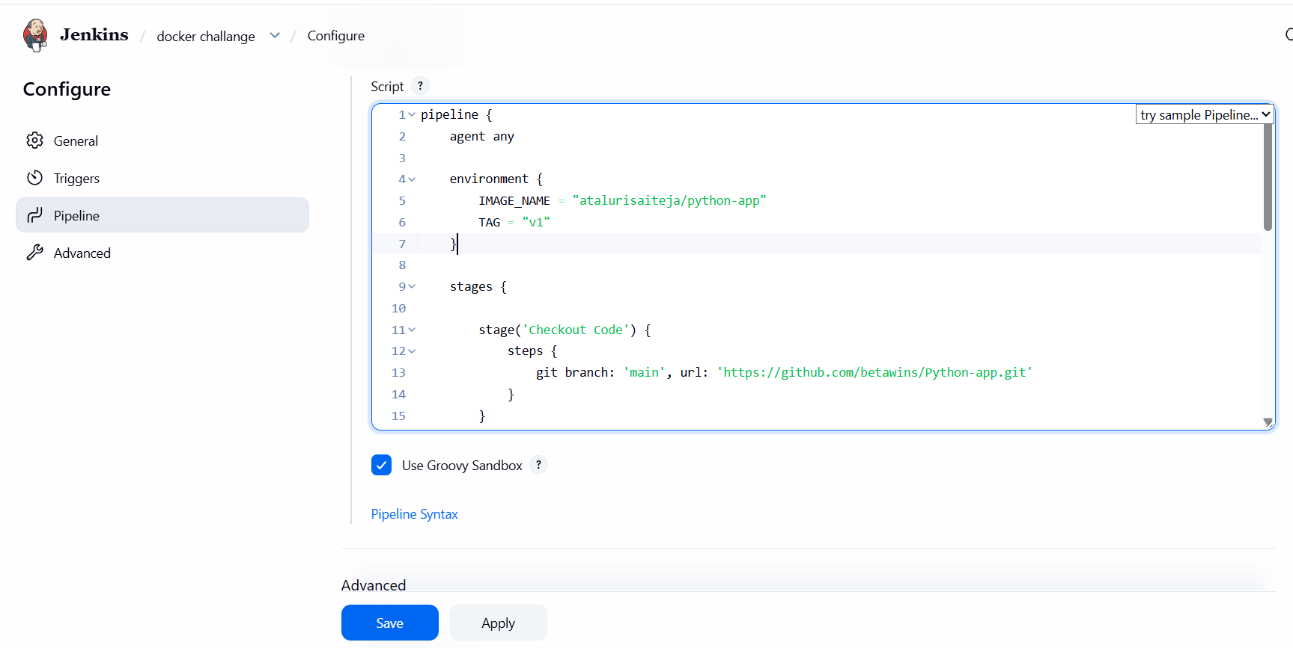
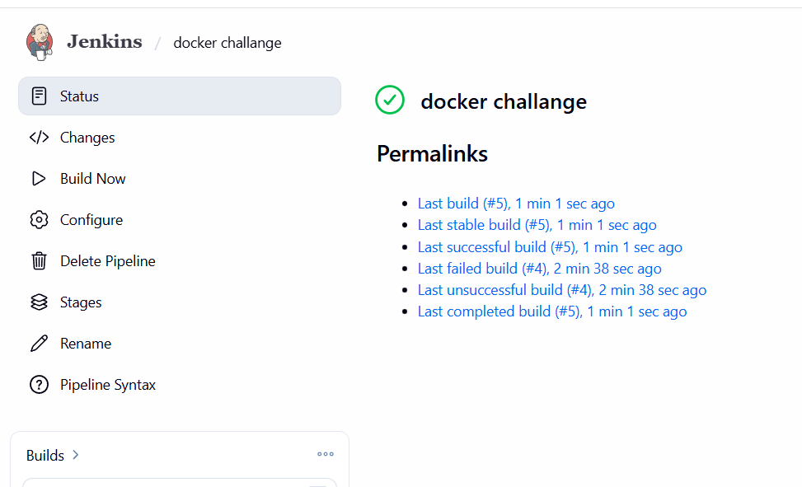
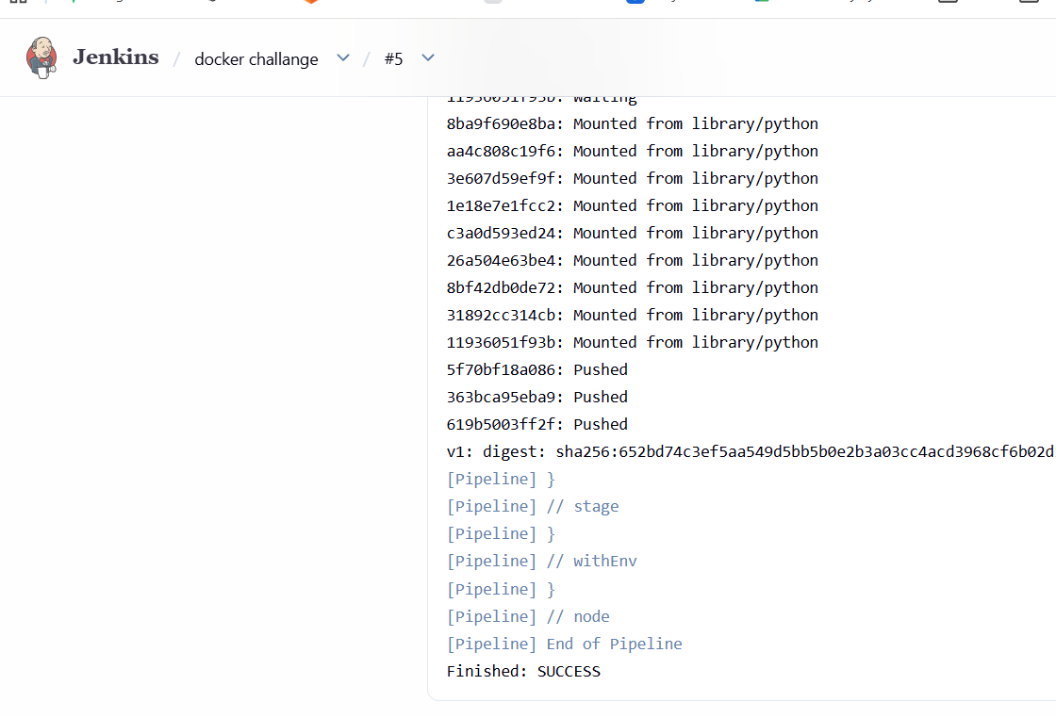

Result
- Docker image is built successfully
- Image is pushed to Docker Hub repository
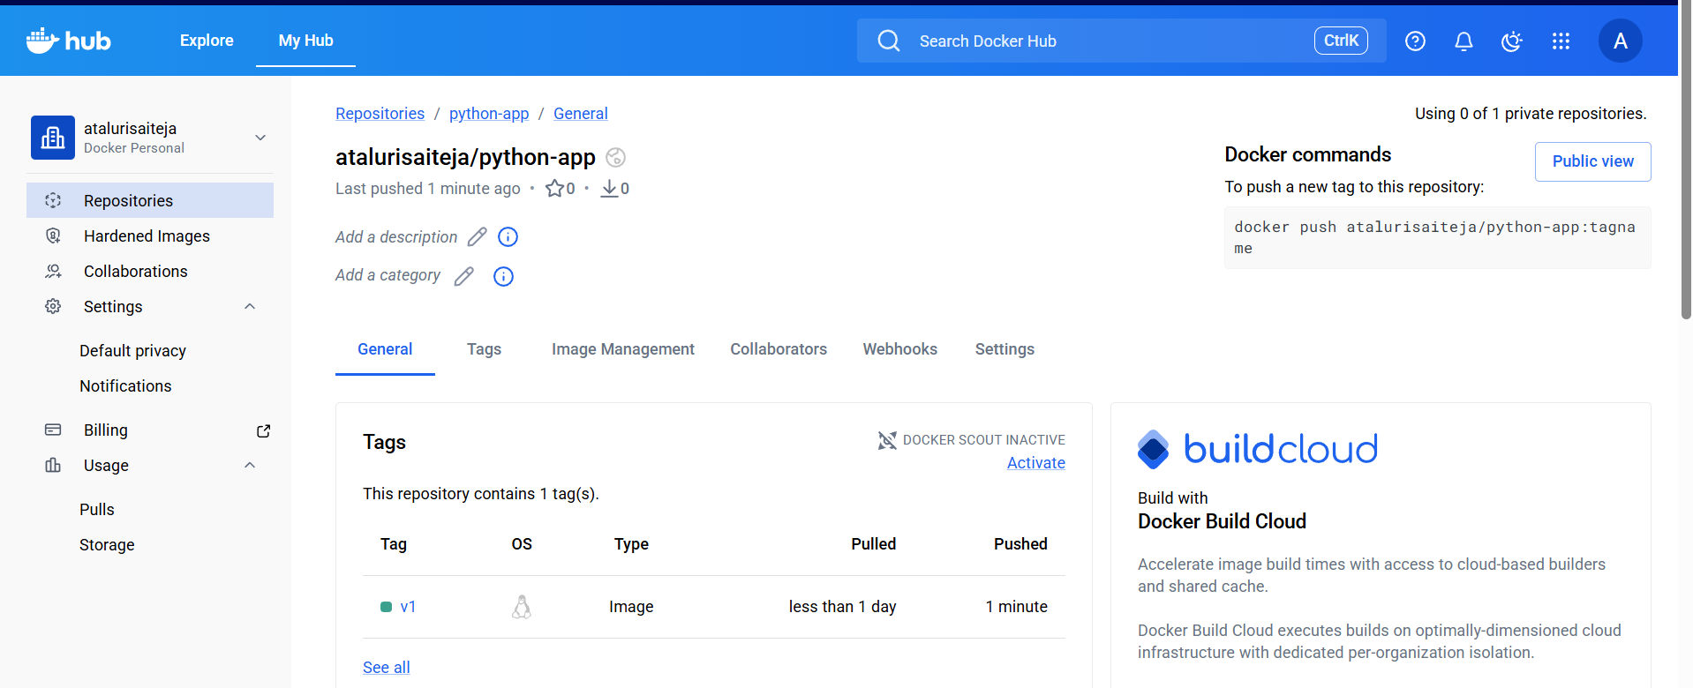
Pipeline Syntax:
pipeline {
agent any

environment {
IMAGE_NAME = "atalurisaiteja/python-app"
TAG = "v1"
}

stages {

stage('Checkout Code') {
steps {
git branch: 'main', url: 'https://github.com/betawins/Python-app.git'
}
}

stage('Build Image') {
steps {
sh 'docker build -t $IMAGE_NAME:$TAG .'
}
}

stage('Login to DockerHub') {
steps {
withCredentials([usernamePassword(
credentialsId: 'dockerhub-creds',
usernameVariable: 'USER',
passwordVariable: 'PASS'
)]) {
sh 'echo $PASS | docker login -u $USER --password-stdin'
}
}
}

stage('Push Image') {
steps {
sh 'docker push $IMAGE_NAME:$TAG'
}
}
}
}

Errors I Faced:
permission denied while trying to connect to the Docker daemon socket
unix:///var/run/docker.sock
👉 Jenkins is running as user jenkins
👉 Docker daemon socket is owned by root:docker
👉 jenkins user does not have permission to use Docker
This is the #1 most common Jenkins + Docker issue.

FIX (Correct & Recommended)
🔹 Step 1: Add jenkins user to Docker group
sudo usermod -aG docker jenkins
🔹 Step 2: Restart Docker
sudo systemctl restart docker
🔹 Step 3: Restart Jenkins
sudo systemctl restart Jenkins
This step is mandatory — group changes don’t apply until restart.
🔹 Step 4: Verify (Optional but Good)
sudo su - jenkins
docker ps
If no error → permissions are fixed
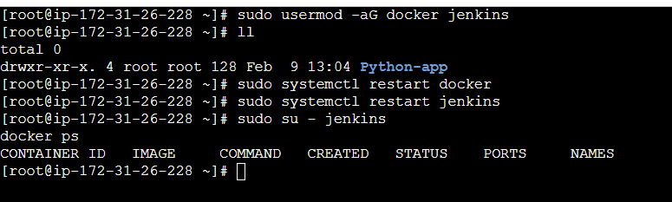
Conclusion
A Jenkins job was successfully created to automate building a Docker image and pushing it to Docker Hub, demonstrating CI/CD integration using Jenkins and Docker.

Title:
Source Codes: https://github.com/betawins/docker-tasks.git
From the frontend source code, write a Dockerfile, build a Docker image, run it, and push that image to your Docker registry.

Objective:
To create a Dockerfile for frontend source code, build a Docker image, run the container, and push the image to a Docker registry.
Step 1: Frontend Project Structure
frontend-app/
├── index.html
└── Dockerfile
Step by Step Implementation
Step 1: Navigate to github repo link and clone the repo in server
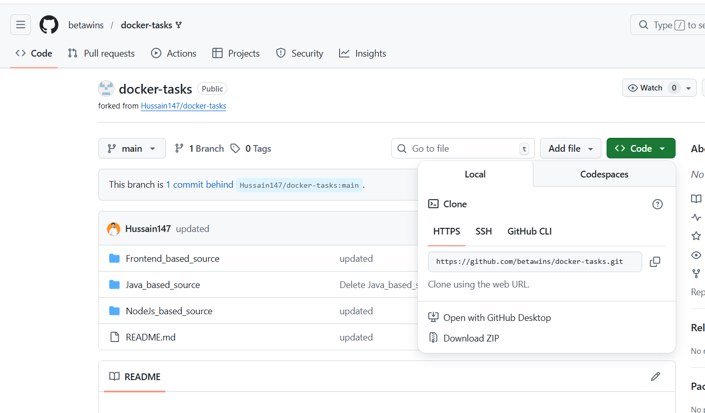

Step 2: create a dedicated directory and clone the repo
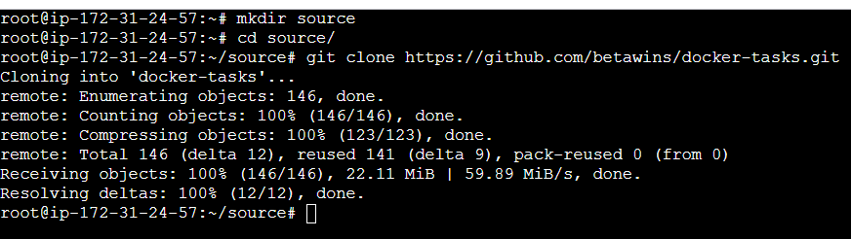
Change the dir to Frontend_based_source
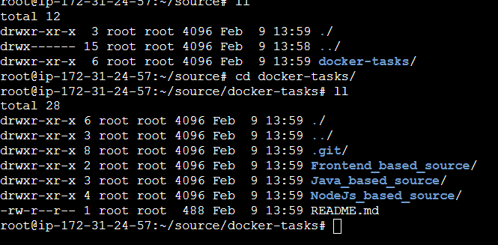
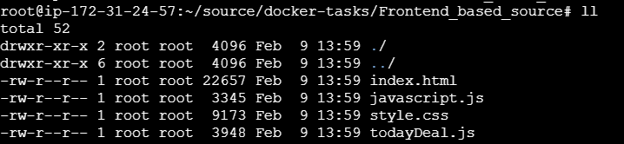
Step 3: Write Dockerfile (Frontend)
Vi dockerfile
#1. Base module as nginx:latest
FROM nginx:latest

#2. Maintainer your name
LABEL maintainer="saiteja"

#3. remove default content
RUN rm -rf /usr/share/nginx/html/*

#4. copy one index.html file to image
COPY index.html /usr/share/nginx/html/index.html

#5. Expose on port 80
EXPOSE 80

CMD ["nginx", "-g", "daemon off;"]
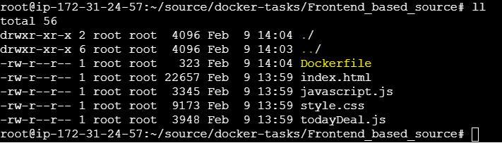
Step 4: Build Docker Image
docker build -t atalurisaiteja/frontend-app:v1 .
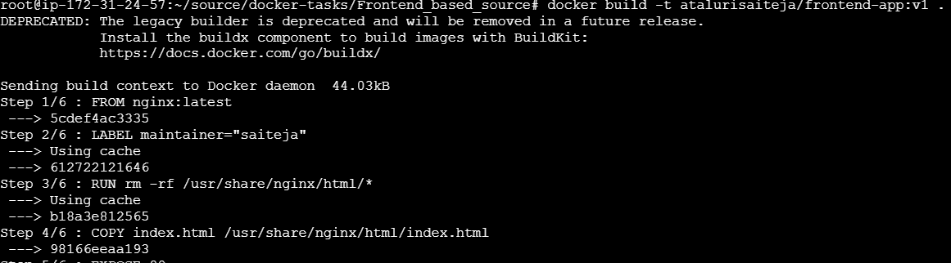
Step 5: Run Docker Container
docker run -d -p 8080:80 <dockerhub-username>/frontend-app:v1
and verify containers
Step 6:
Access in browser:
http://localhost:8080
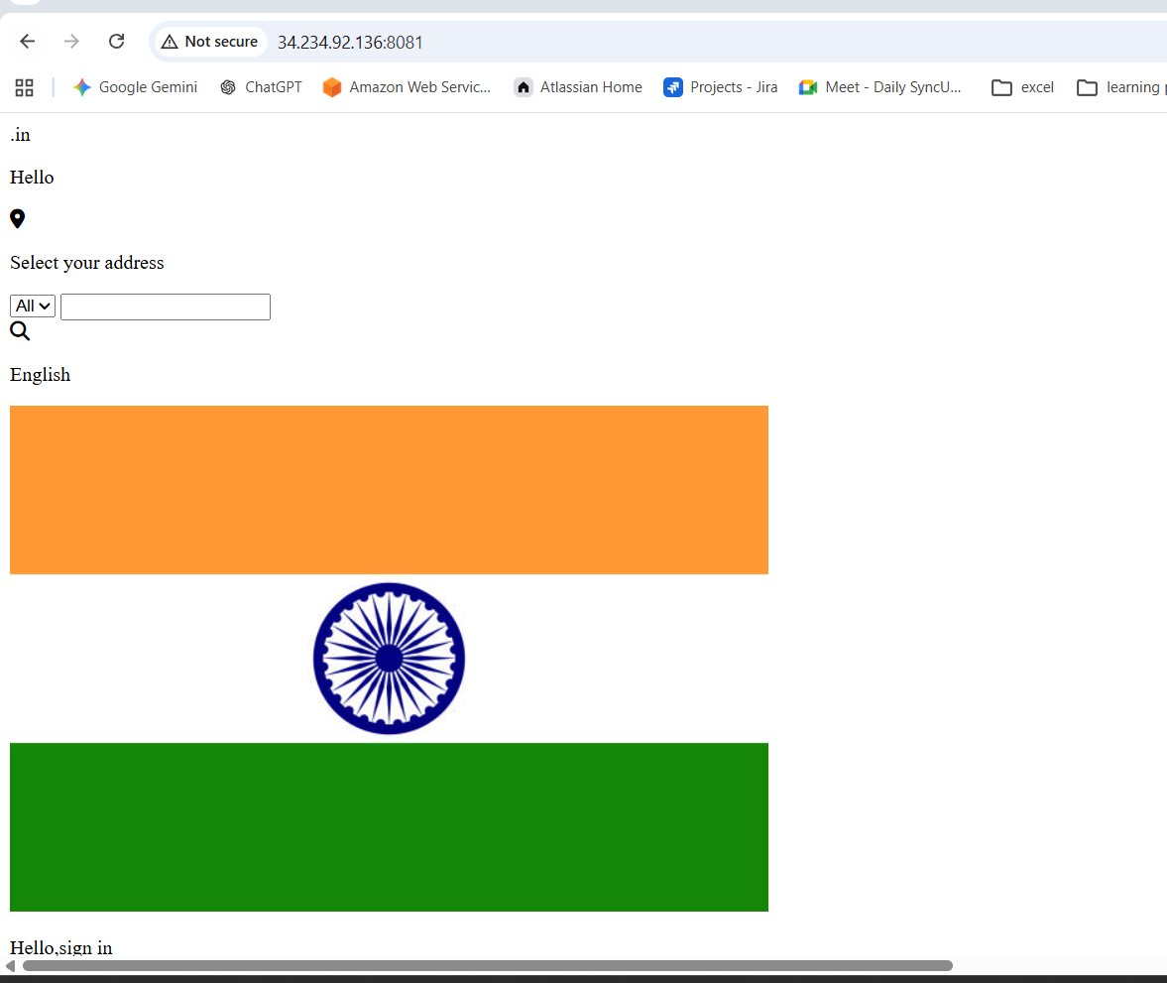
Step 7 : Login to Docker Registry
docker login
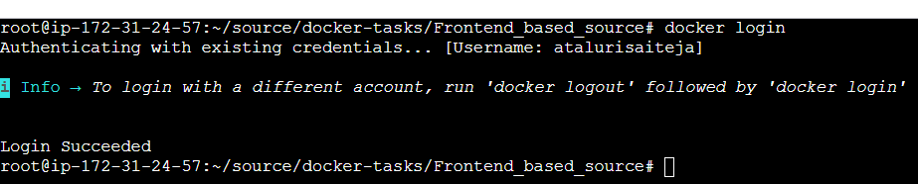

Step 8: Push Image to Docker Registry
docker push atalurisaiteja/frontend-app:v1
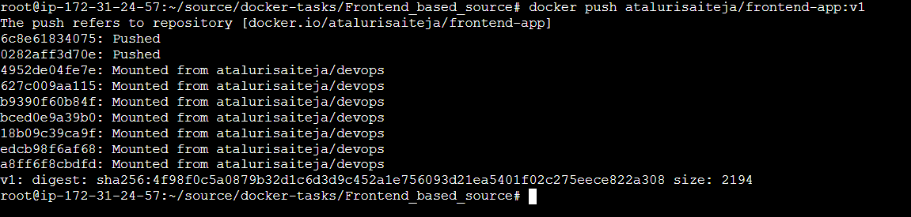
Result:
- Frontend source code containerized using Docker
- Docker image built and tested locally
- Image successfully pushed to Docker registry
Conclusion:
The frontend application was successfully containerized using Docker, executed as a container, and pushed to a Docker registry for reuse and deployment.

Title:
From the Java-based source code, write a Dockerfile, build, run, and push the image to the Docker registry.
Objective
To containerize a Java-based application using Docker, build and run the Docker image, and push it to a Docker registry.

Step 1: Java Project Structure (Example)
java-app/
├── Dockerfile
Step by Step Implementation:
Step 1:
Change the dir to java based source
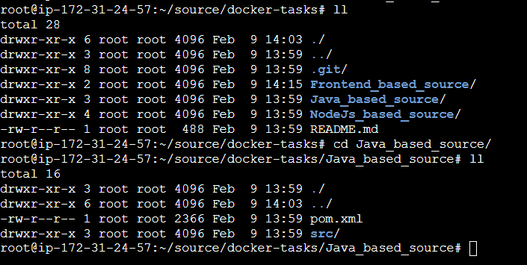

Step 2: Create a Docker file
Vi docker file
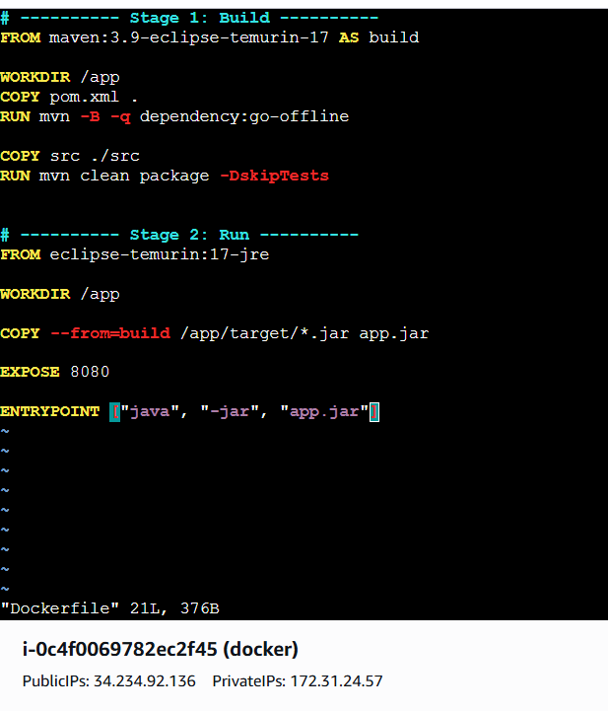
Syntax for Docker file
# ---------- Stage 1: Build ----------
FROM maven:3.9-eclipse-temurin-17 AS build

WORKDIR /app
COPY pom.xml .
RUN mvn -B -q dependency:go-offline

COPY src ./src
RUN mvn clean package -DskipTests

# ---------- Stage 2: Run ----------
FROM eclipse-temurin:17-jre

WORKDIR /app

COPY --from=build /app/target/*.jar app.jar

EXPOSE 8080

ENTRYPOINT ["java", "-jar", "app.jar"]

Step 3: Build Docker Image
docker build -t <dockerhub-username>/java-app:v1 .
Example:
docker build -t atalurisaiteja/java-app:v1 .
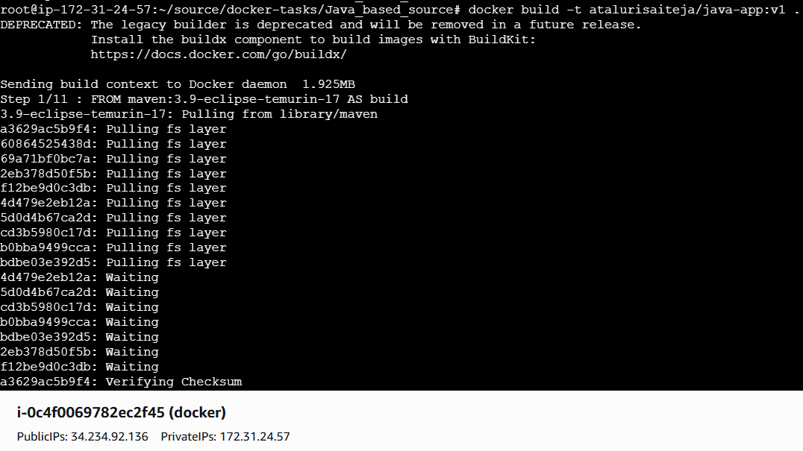
Also Verify the Images
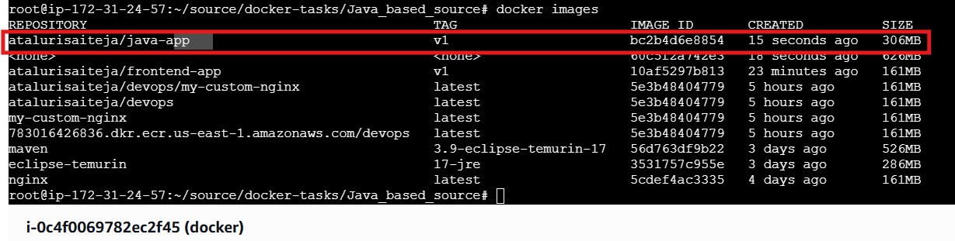Step 4: Run Docker Container
Docker run -itd -p 19999:8080 atalurisaiteja/java-app:v1
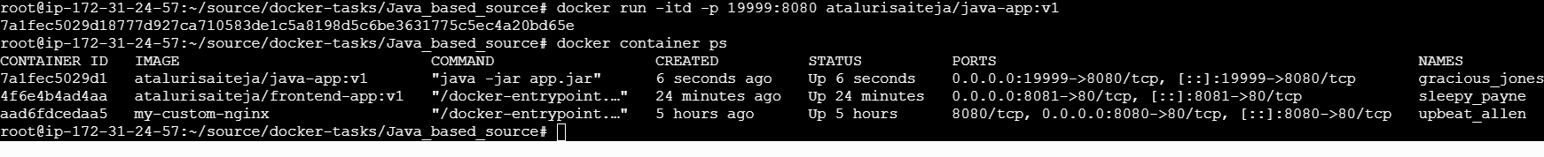
Step 5: Verify on browser
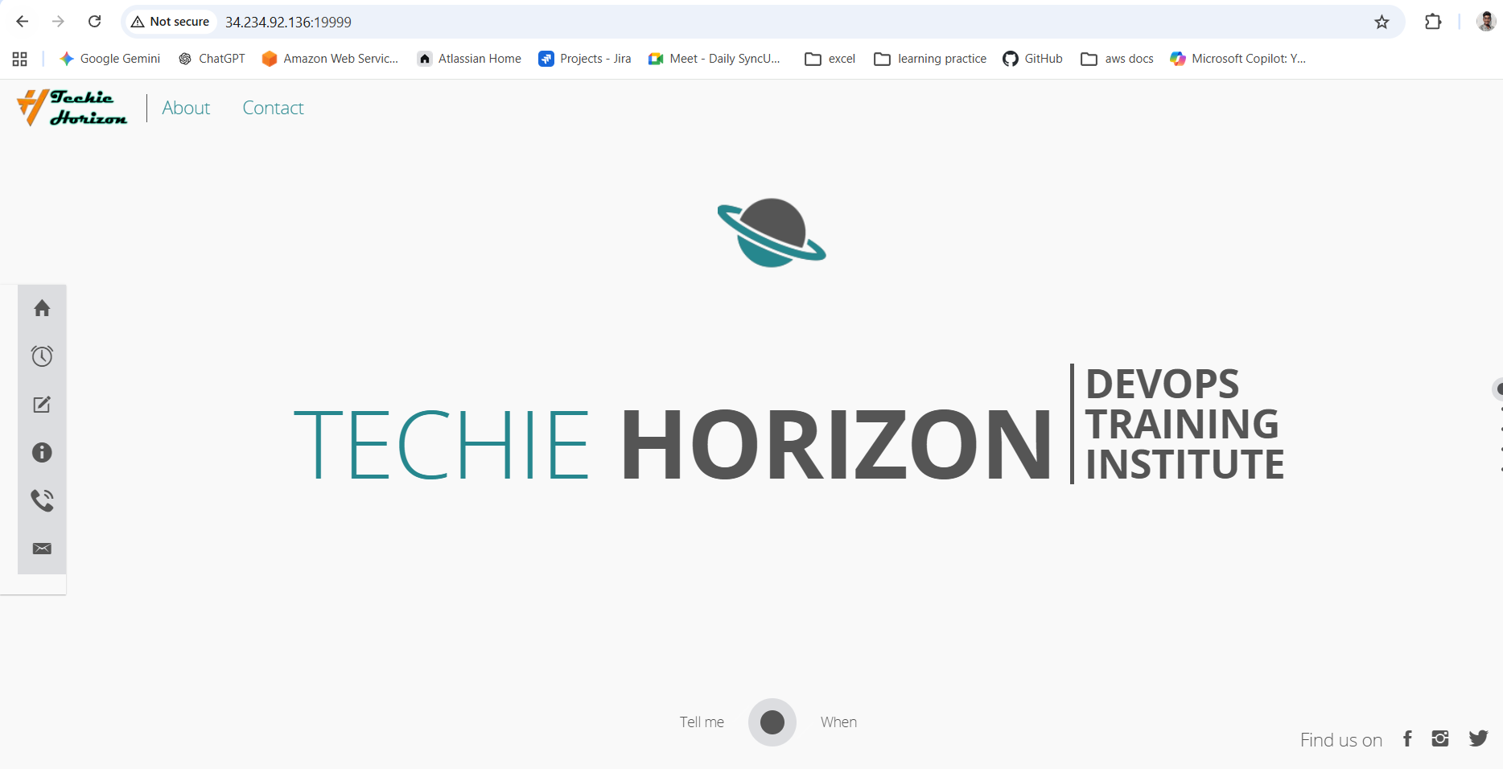
Step 6: Login to Docker Registry
docker login


Step 6: Push Image to Docker Registry
docker push <dockerhub-username>/java-app:v1
Example:
docker push atalurisaiteja/java-app:v1
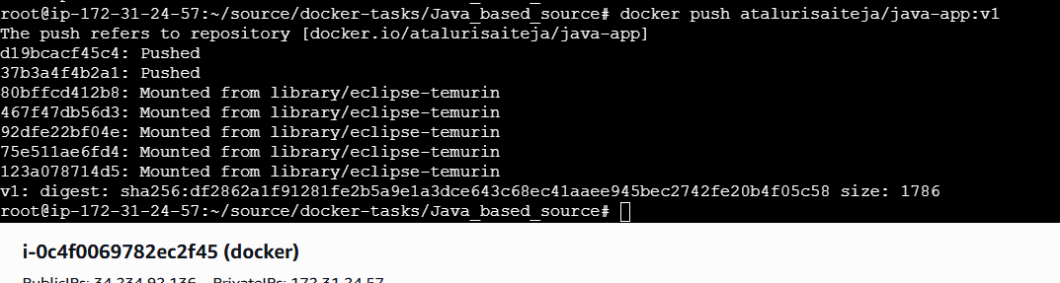
Verified on docker hub
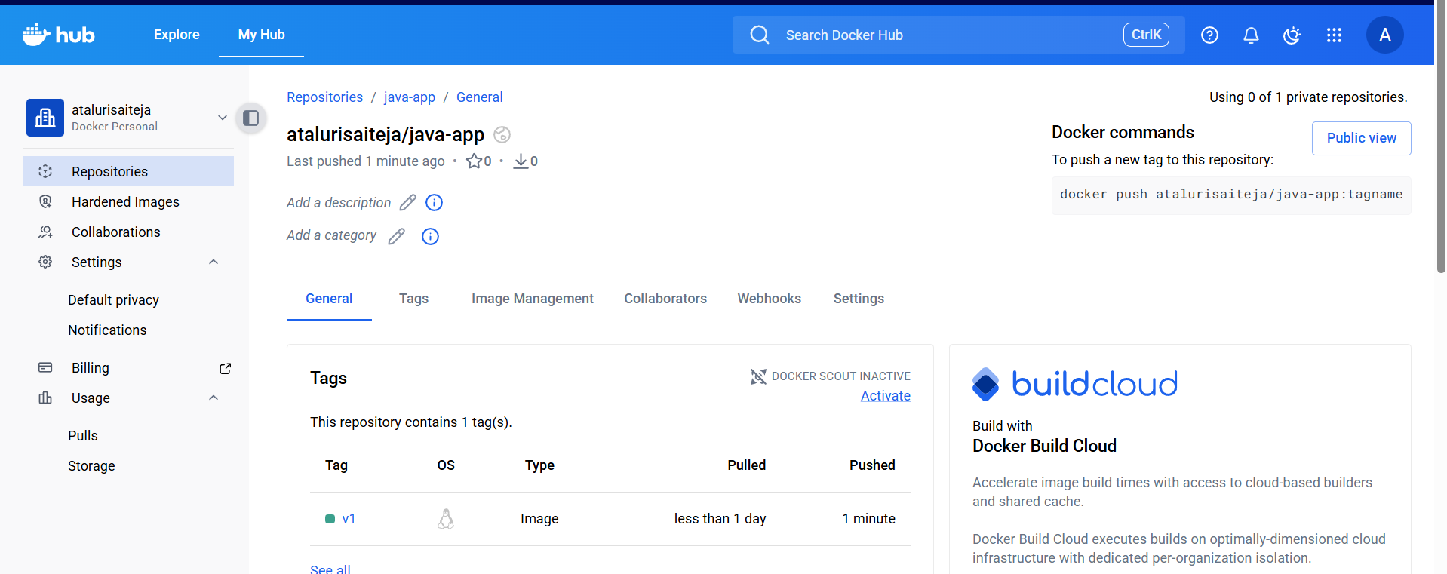
Result
- Java application was successfully containerized
- Docker image was built and executed
- Image was pushed to Docker registry

Conclusion
The Java-based application was successfully containerized using Docker and pushed to a Docker registry, enabling easy deployment and reuse.

Title:
From the Node.js-based source code, write a Dockerfile, build with tag v1, run, and push it to the Docker registry.
Objective
To containerize a Node.js application using Docker, build the image with tag v1, run the container, and push the image to a Docker registry.
Step 1: Node.js Project Structure
node-app/
└── Dockerfile
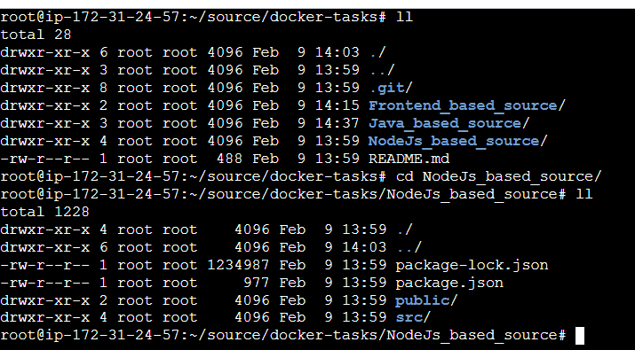
Step 2: Write Dockerfile
FROM node:18-alpine

# create app directory
WORKDIR /app

# copy dependency files first (cache optimization)
COPY package*.json ./

# install dependencies
RUN npm install

# copy remaining source code
COPY . .

EXPOSE 3000

CMD ["npm", "start"]
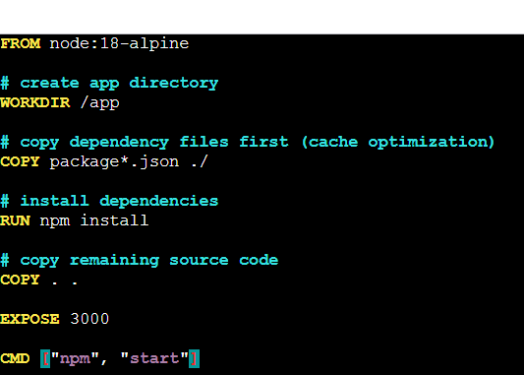

Step 3: Build Docker Image with Tag v1
docker build -t <dockerhub-username>/node-app:v1 .
Example:
docker build -t atalurisaiteja/node-app:v1 .
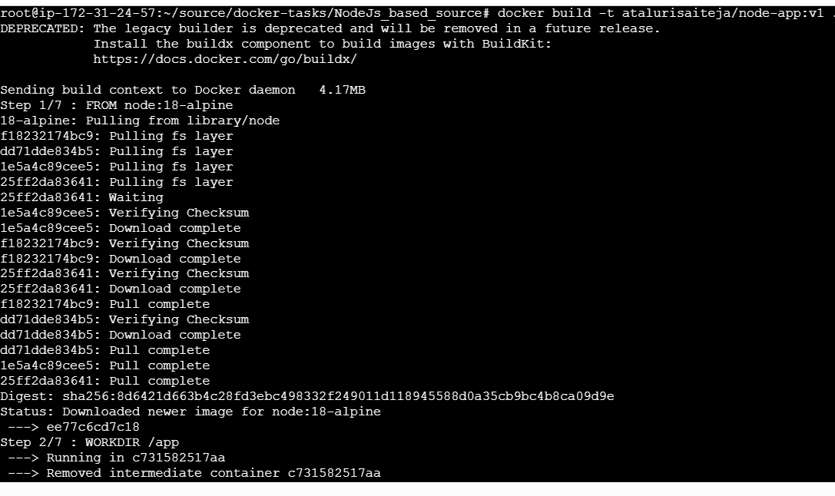
Step 4: Run Docker Container
docker run -d -p 3000:3000 <dockerhub-username>/node-app:v1
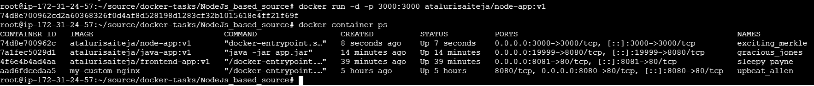

Access in browser:
http://localhost:3000

Step 5: Login to Docker Registry
docker login

Step 6: Push Image to Docker Registry
docker push <dockerhub-username>/node-app:v1
Example:
docker push atalurisaiteja/node-app:v1
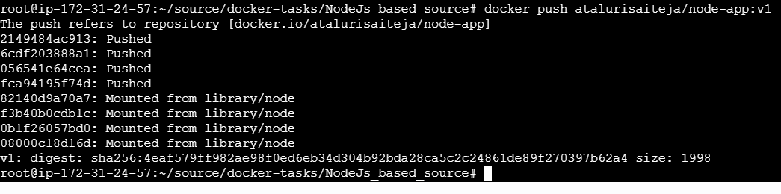

Verified in Docker hub
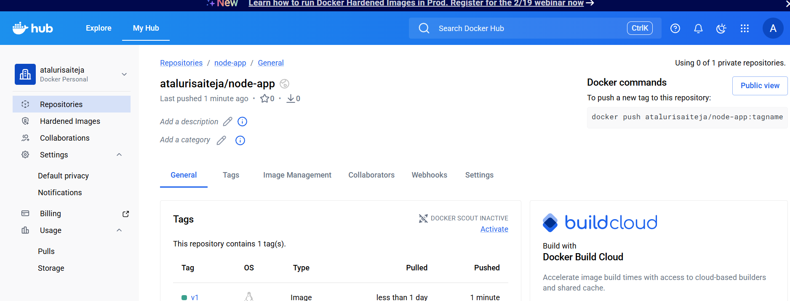

Result
- Node.js application containerized using Docker
- Docker image built with tag v1
- Container executed successfully
- Image pushed to Docker registry

Conclusion
The Node.js application was successfully containerized, executed, and pushed to a Docker registry, enabling easy deployment and portability.

Title:
Write a docker-compose file to set up WordPress with a MySQL database.
docker-compose.yml (WordPress + MySQL)
version: '3.8'

services:
db:
image: mysql:5.7
container_name: wordpress-db
restart: always
environment:
MYSQL_DATABASE: wordpress
MYSQL_USER: wpuser
MYSQL_PASSWORD: wppassword
MYSQL_ROOT_PASSWORD: rootpassword
volumes:
- db_data:/var/lib/mysql

wordpress:
image: wordpress:latest
container_name: wordpress-app
restart: always
ports:
- "8080:80"
environment:
WORDPRESS_DB_HOST: db:3306
WORDPRESS_DB_USER: wpuser
WORDPRESS_DB_PASSWORD: wppassword
WORDPRESS_DB_NAME: wordpress
depends_on:
- db
volumes:
- wp_data:/var/www/html

volumes:
db_data:
wp_data:

Run
docker-compose up -d
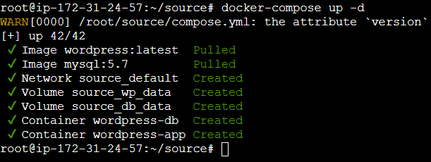
Access WordPress
Open browser:
http://localhost:9000
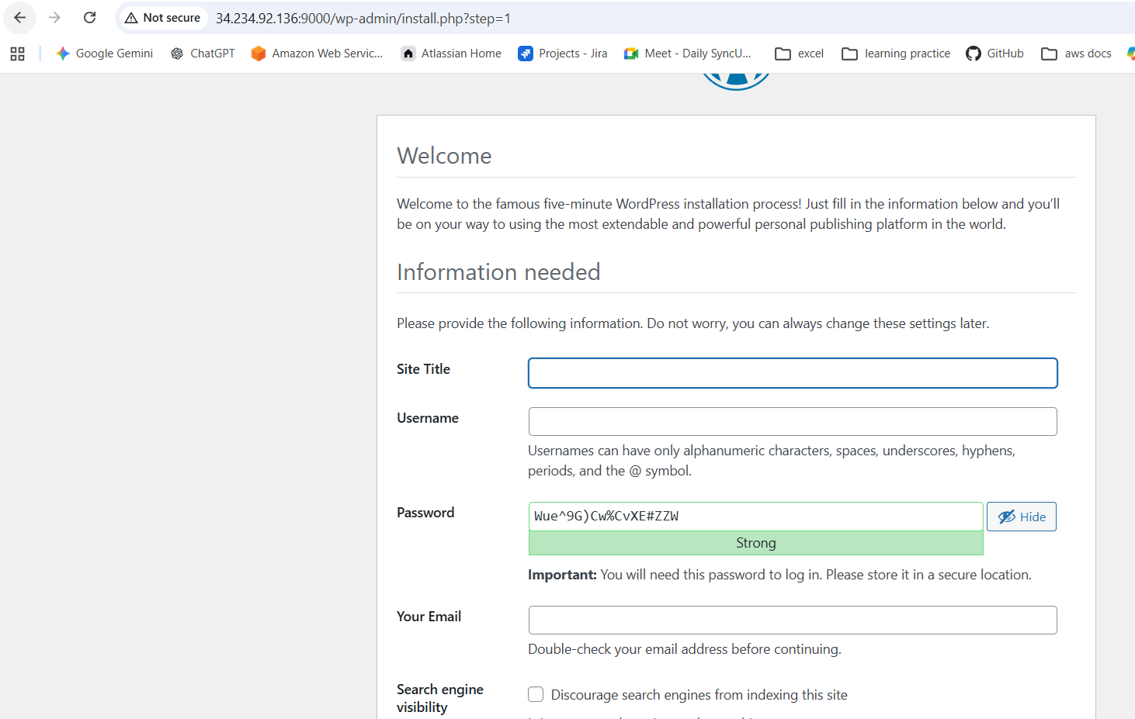
What This Does
- MySQL container stores WordPress database
- WordPress container connects to MySQL using service name db
- Volumes ensure data persistence
- Port 9000 exposes WordPress

Stop & Remove Containers
docker-compose down
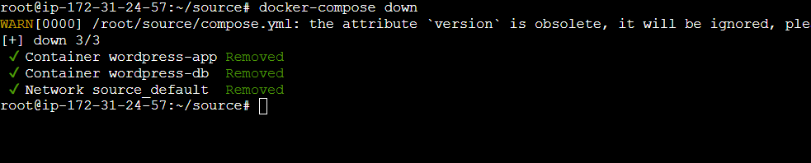
Conclusion
Docker Compose was used to deploy WordPress with a MySQL database in a multi-container setup, enabling easy configuration and persistent data storage.

